How many times do I look at my phone? In this post I show  
what went wrong and how to plot the results.

**The data**

I set up a small program on my phone that counts every day how many times I use  
my phone (to be specific, it counts the times the screen has been activated).

My data looks like this:

"screen_log";"1-19-19";"17.30";"7"

"screen_log";"1-19-19";"17.33";"8"

"screen_log";"1-19-19";"17.36";"9"

"screen_log";"1-19-19";"17.38";"10"

To account for comma use and possible problems I set up the program on my  
phone to write a “;”-seperated file that records screen_log, the date, the  
time and the current value of screen_count. Every day around 12 o clock it reset  
the counter to 0.  
I thought it would be cool to compare different days.

**The problems**

I started the data collection on januari 19th around 17:00h, so the first day  
is already halfway through.  
For reasons I cannot fathom, sometimes the system date is recorded in the USA  
style MONTH-DAY-YEAR and sometimes in the rest-of-the-world style of DAY-MONTH-YEAR.  
I wish I could set it to YEAR-MONTH-DAY (ISO 8601).

**Reading in the data**

I use read_csv2, which expects “;” as a seperator and never converts text to factor.  
This particular textfile has no headers, so I tell R what to call the columns.

library(tidyverse) # what else

screenlog <- read_csv2("data/screenlog.csv",col_names = c("type","date","time","counter"))

**Data cleaning**

I have to deal with the different time formats, so I set up a regex that works  
only with Januari, if it detects -01-19 it pulls out the numbers before that,  
if it detects the other variant it takes the second part.  
I combine the date and time into a timestamp and pull out the hours and minutes,  
before combining the hours and minutes into HMS time class.  
Finally I remove anything over 23 hours, because in that period the counter is  
reset.

screenlog <-

screenlog %>%

mutate(

day = case_when(

str_detect(date, "[0-9]{1,2}-01-19") ~

str_replace(date, "([0-9]{1,2})-01-19","\\1"),

str_detect(date, "1-[0-9]{1,2}-19") ~

str_replace(date, "1-([0-9]{1,2})-19", "\\1") ,

TRUE ~ NA_character_

),

timestamp = paste0("2019-01-",day, " ",time),

timestamp = as.POSIXct(timestamp,tz = "GMT", format = "%Y-%m-%d %H.%M"),

hours = str_replace(time,"\\.[0-9]{1,2}", "") %>% as.numeric(),

minutes = str_replace(time,"[0-9]{1,2}\\.", "") %>% as.numeric(),

time = hms::hms(hours = hours, minutes = minutes)

) %>%

filter(hours < 23)

**How does it look?**

First an overview:

screenlog %>%

ggplot(aes(timestamp, counter, color = day))+

geom_step()+

ggtitle("Times I looked at my screen during vacation", subtitle = "daily values")+

theme_light()

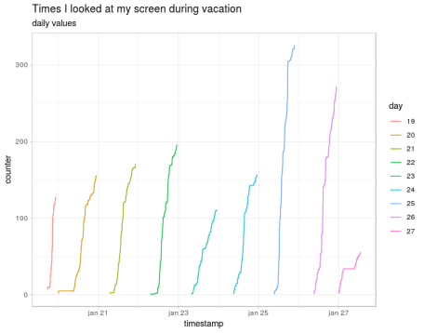

Daily cumulative screen looking values

But that is difficult to compare, so I also show them overlayed:

screenlog %>%

ggplot(aes(time, counter, group = day, color = day))+

geom_step()+

ggtitle("Times I looked at my screen during vacation", subtitle = "overlay plot")+

theme_light()

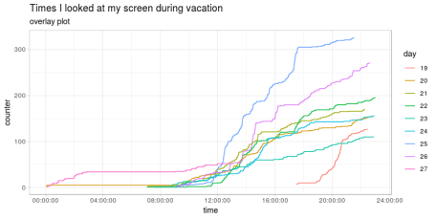

overlay of cumulative screen lookings every day on the same hourly scale

**Fin**

The only remaining question is: what did I do on the 25th that I looked soooo (326 times) many  
times on my screen?  
Is there a bug in the counting? Was I really bored, did I take a lot of photo’s?  
I was in the Botanical Gardens of Malaga and did take a lot of pictures with my  
phone.